ECE 375 Lab 3
Simulation

Lab Time: Thursday 1000-1200

Eric Prather

Introduction
IMPORTANT: This lab does not require a writeup. This is stated explicitly in the Lab 3 Handout:
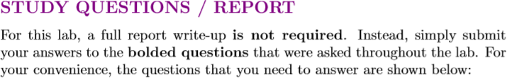

Prelab Questions
1. What are some diﬀerences between the debugging mode and run mode of the AVR simulator? What do you think are some beneﬁts of each mode?
In computer science, debug and run mode are two distinct sets of preprocessor directives and execution environments. Code compiled for a debug build will often not have certain subroutines condensed and comes with additional reflection data, whereas the final release tends to be fully compressed and optimized. Debug builds additionally possess additional metadata related to the program code allowing for advanced execution behaviors such as break-pointing and member value inspection. In C, common debugging software which uses this metadata include the Visual Studio Profiler and the GDB command line utility. The assembly equivalent of this, for the purposes of this class, is the AVR simulator’s debug and release modes. The AVR debug mode allows the management of the program through metadata which, at a core level, can make inferences about and modify program state using an external set of metadata (not unlike the .NET framework reflection library) superimposed on the simulated hardware events. However, despite these clear advantages of debug mode, no debug compilation can ever perfectly represent a release build, so testing should always be done in the latter as well to prepare best for the deployment to the hardware.
2. What are breakpoints, and why are they useful when you are simulating your code?
Breakpoints are metadata flags that are used to correlate source-code lines with compiled machine code execution states. A developer can insert a breakpoint in program code and then a debug compiler will automatically generate the necessary metadata for that breakpoint to be observed in the execution environment. The most common use of breakpoints is to pause programs mid-execution so programmers can inspect the state of the program’s stack and all of the data at certain pre-defined points while searching for the source of an error.
3. Explain what the I/O View and Processor windows are used for. Can you provide input to the simulation via these windows?
The IO windows show the status of the simulated IO pins and their associated registers (e.g. DDRX, PORTX, PINX). The processor window shows the state of the processor components. IO can be provided by the IO view. The simplest way to do this is by clicking on the bit checkboxes,, but you can also type in values in the value fields. Not all registers are immediately exposed through the I/O window.
The processor window is similar, but instead of displaying special external or IO registers on the board, it displays those on the inside of the processor. You can similarly provide values to the registers like with the I/O window.
4. The ATmega128 microcontroller features three diﬀerent types of memory: data memory, program memory, and EEPROM. Which of these memory types can you access by using the Memory window of the simulator?
(a) Data memory only
(b) Program memory only
(c) Data and program memory
(d) EEPROM only
(e) All three types
The memory window of the simulator shows (e) all three types of memory. This is despite the fact that the program memory is not accessible by the microcontroller itself, so it does not make sense to show it in the debugger. Program memory wouldn’t be useful to a debugger anyway. EEPROM is also not pertinent. It is static over the course of the simulation. Nevertheless, the inclusion of all of these types of memory is valuable for the sake of learning.

Lab Questions
1. What is the initial value of DDRB?
The initial value of the register DDRB is 0b000000:
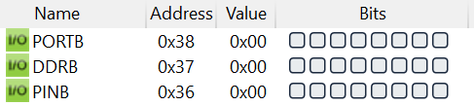
2. What is the initial value of PORTB?
The initial value of port b is 0b00000000
3. Based on the initial values of DDRB and PORTB, what is Port B’s default I/O conﬁguration?
Using the values from questions 1 and 2, we can determine that Port B’s default I/O configuration is input with no pullup on all pins.
4. What 16-bit address (in hexadecimal) is the stack pointer initialized to?
After hitting the next breakpoint, the stack pointer is set to 0x10FF.
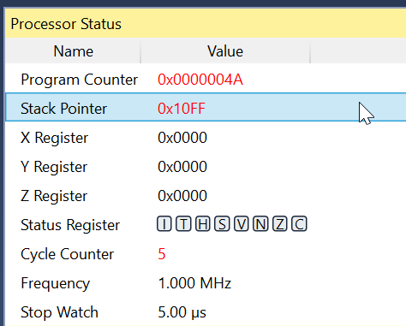
5. What are the contents of register r0 after it is initialized?
After r0 is initialized, it contains the value 0xFF. This is odd because I would have expected an instructor called “clear” to set it to 0x00, but I guess that just goes to show what I know.
6. How many times did the code inside of LOOP end up running?
After waiting at breakpoint #2, I pressed “continue” 5 times until I reached breakpoint #4. During this time, I landed on breakpoint #3 4 times. From this, I can tell that the loop executed four (4) times. The last “continue” did not jump back to the beginning of the loop, which is why I don’t count it as five total loop executions.
7. Which instruction would you modify if you wanted to change the number of times that the loop runs?
I would modify the instruction “ldi i, $04” to make the loop run a different number of times. The third word on this line should change to modify it. Every time the loop executes, the value is decremented by one. Once the value is zero, the loop does not repeat.
Unnumbered Question: What are the current contents of register r1?
At breakpoint #4, register 1 is 0xAA
8. What are the contents of register r1 after it is initialized?
This question is never asked in the actual body of the lab- it just appears in the list of questions at the end. Did you mean “What are the current contents of r1”? If so, that is answered in the item labeled “Unnumbered Question”. Important: This question appears directly after numbered question #7, which is highly suspect as an error, because it has nothing to do with the other two questions in the block of questions numbered 6 to 7. Screenshot:
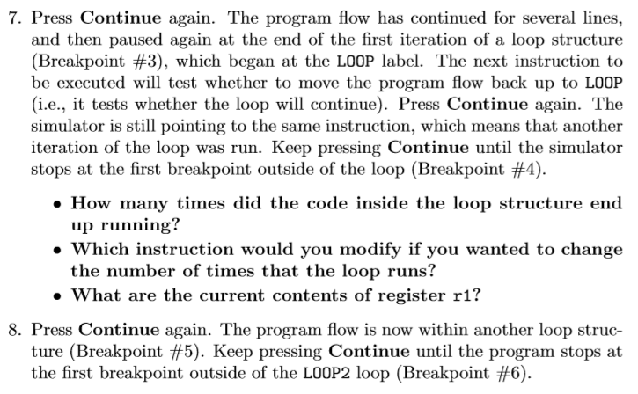
9. What are the contents of register r2 after it is initialized?
This question does not occur in this lab. Did you mean the similar question “What are the current contents of register r2”? If so, the answer is as follows:
r2 contains 0x0F.
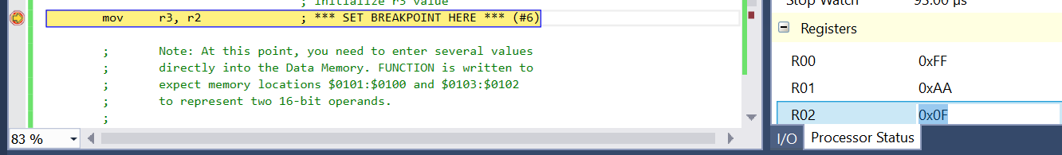
This question appears in the text as:
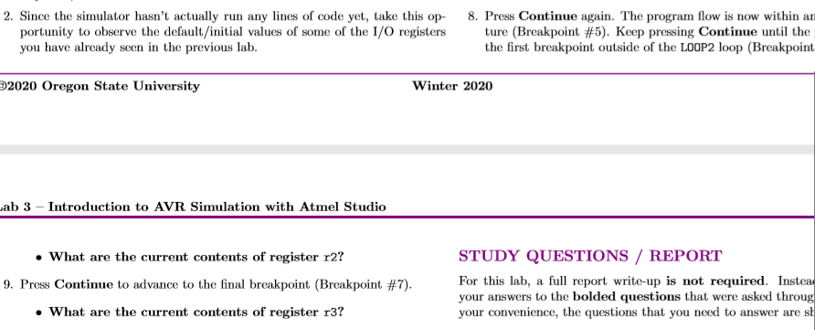
10. What are the contents of register r3 after it is initialized?
This question does not occur in this lab. Did you mean the similar question “What are the current contents of register r2”? If so, the answer is as follows:
r3 contains 0x0F.
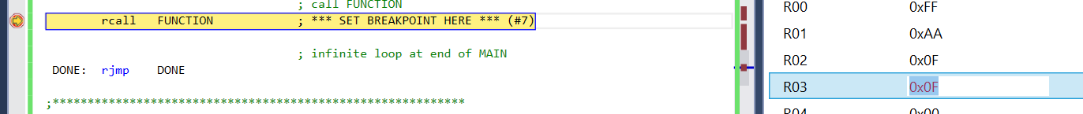
This question appears in the text as:
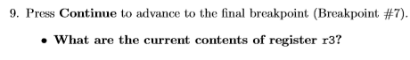
11. What is the value of the stack pointer when the program execution is inside the FUNCTION subroutine?
The value of the stack pointer inside of this function is 0x10FD
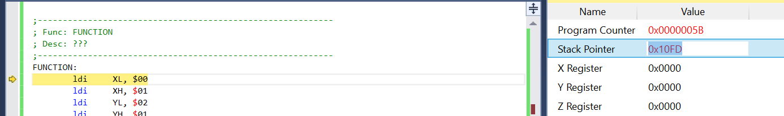
12. What is the ﬁnal result of FUNCTION? (What are the hexadecimal contents of memory locations $0105:$0104)?
The final result of the function is 0x0eba.

Challenge Questions
1. What type of operation does the FUNCTION subroutine perform on its two 16-bit inputs? How can you tell? Give a detailed description of the operation being performed by the FUNCTION subroutine.
FUNCTION performs the following C pseudocode:
// X = $0100, Y = $0102, Z = $0104
FUNCTION(*X, *Y, out Z):
A = *X
X++ // $0102
B = *Y
Y++ // $0104
B = B + A
*Z = B
Z++ // $0106
A = X
B = Y
B = B + A (carry from last sum included)
*Z = B
Z++ // $0108
If(no carryover bit)
Return;
Else
*Z = XH
In plain English, this can be described as follows:
FUNCTION sums the values at X and Y in memory and stores them at Z in memory, where X, Y, and Z are contiguous 16-bit values from $0100 to $0105. Next, it adds *Z, *Y, and the carryover- storing the new carryover in a special register pin. This second sum is stored in the byte following Z’s original address (because z was earlier post-incremented). Lastly, if there is a carryover bit, it writes the next 8 bits following where the previous sum was stored with the most significant 8 bits of X.
In even simpler terms:
Sums two inputs, stores the result, then sums the result and the second input. Writes to designated output area. All bytes are in reverse endian (rightmost bytes are more significant than leftmost bytes).
Mathematically:
OUTPUT = INPUT 1 + 2* INPUT2
2. Currently, the two 16-bit inputs used in the sample code cause the “brcc EXIT” branch to be taken. Come up with two 16-bit values that would cause the branch NOT to be taken, therefore causing the “st Z, XH” instruction to be executed before the subroutine returns.
Adding 0xFF and 0xFF would do the trick, because it would overflow in the addition operation. If we want the extra statement to execute, that would work nicely.
3. What is the purpose of the conditionally-executed instruction “st Z, XH”?
It is possible that the sum results in a number that is too big to be stored in 2 bytes. In order to output the whole number, which may take three bytes, the new most significant byte is tacked onto the “beginning” of the sum if necessary.

